**Project Design Phase-II**

**Technology Stack (Architecture & Stack)**

|  |  |
| --- | --- |
| Date | 20 October 2022 |
| Team ID | PNT2022TMID43503 |
| Project Name | Natural Disasters Intensity Analysis and Classification using Artificial  Intelligence |

**Technical Architecture:**

The Deliverable shall include the architectural diagram as below and the information as per the table1 & table 2

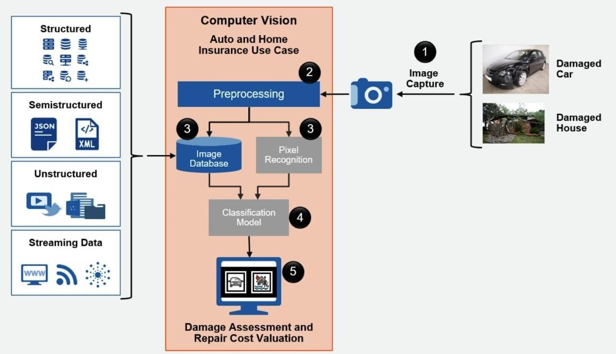

**Table-1 : Components & Technologies:**

|  |  |  |  |
| --- | --- | --- | --- |
| **S.No** | **Component** | **Description** | **Technology** |
| 1. | User Interface | The user/client can access the functionalities in the system through user interface. | HTML5, CSS, JavaScript Technologies |
| 2. | Application Logic-1 | The code for the DR detection process can be programmed using python | Python |
| 3. | Application Logic-2 | Watson is an IBM supercomputer that combines artificial intelligence (AI) and sophisticated analytical software for optimal performance as a "question answering" machine. | IBM Watson STT service |
| 4. | Application Logic-3 | Watson Assistant lets you build conversational interfaces into any application, device, or channel. Add a natural language interface to your application to automate interactions with your end users. | IBM Watson Assistant |
| 5. | Database | Here we use database to organize the collection of information. | MySQL, NoSQL, etc. |
| 6. | Cloud Database | We will use the storage functionality and cloud functions provided by firebase for the development of the backend. | IBM DB2, IBM Cloudant etc. |
| 7. | File Storage | Images are stored for further analysis purposes. | IBM Block Storage. |
| 8. | External API-1 | This application is used for recognition of image, videos and face in photos etc. | IBM Weather API, etc. |
| 9. | External API-2 | It can be used for constructing and executing a TensorFlow graph. | Aadhar API, etc. |
| 10. | Machine Learning Model | Machine Learning Model for processing the image and data. | Object Recognition Model, etc. |
| 11. | Infrastructure (Server / Cloud) | Cloud services are infrastructure, platforms, or software that are hosted by third-party providers and made available to users through the internet. | Local, Cloud Foundry, Kubernetes, etc. |

**Table-2: Application Characteristics:**

|  |  |  |  |
| --- | --- | --- | --- |
| **S.No** | **Characteristics** | **Description** | **Technology** |
| 1. | Open-Source Frameworks | The open-source frameworks used such as Anaconda navigator , jupyter ,spyder , python. | Anaconda app or Google. |
| 2. | Security Implementations | Develop an Incident Management, Disaster Recovery Plan and manage risk. | e.g. SHA-256, Encryptions, IAM Controls, OWASP etc. |
| 3. | Scalable Architecture | It must handle all workloads without any consequences. | IBM Cloud |
| 4. | Availability | Availability of application for all users. | IBM Cloud |
| 5. | Performance | Application should perform correctly . | IBM Cloud |